Conclusions from Warehouse Employees' Performance Dashboard

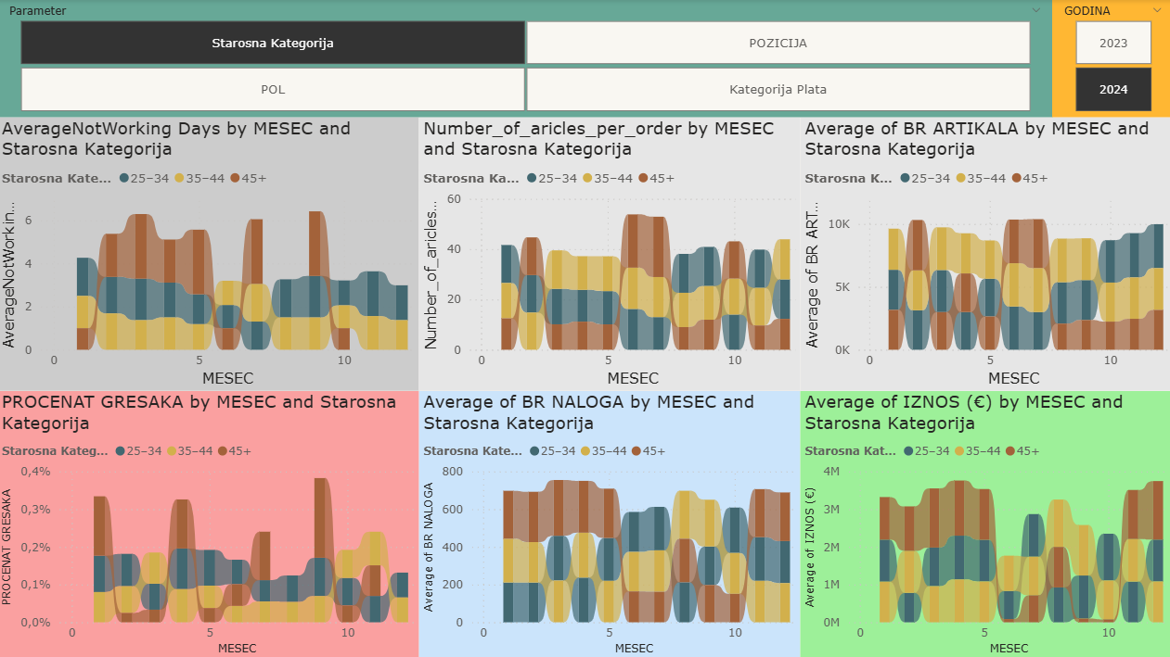
📊 KEY INDICATORS BY AGE CATEGORY

1. 🕒 Average NotWorking Days (Absences)
- Employees aged 45+ have the highest absences throughout the year, especially pronounced in months 5, 6, and 9.
- The 35-44 age group has the fewest absences in almost all months.
🔍 Conclusion: Middle-aged employees have higher presence and potentially greater availability for work.

2. 📦 Number of Articles per Order
Age Group | Average Performance | Stability | Comment
25–34 | 🟢 Moderate | ✅ High | Reliable, without extremes
35–44 | 🟢 Moderate | ✅ High | Experience + reliability
45+ | 🔄 High potential (peaks) | ❌ Low | Uneven performance – excellent when available, but often variable

3. 📈 Average Number of Articles
Age Group | Productivity | Stability | Trend
25–34 | 🟡 Medium | 🟢 Growing | 📈 Significant growth
35–44 | 🟢 High | ✅ Stable | 📊 Consistent
45+ | 🟠 Variable | ❌ Low | 📉 Declining since July

4. 🚩 Error Percentage
Age Group | Error Rate | Stability | Conclusion
25–34 | 🟢 Low (0.1–0.18%) | ✅ High | Reliable and consistent
35–44 | 🟢 Very Low | ✅ High | Most precise team
45+ | 🔴 Highest (up to 0.4%) | ❌ Low | Potential quality risk
The 45+ group has potential for excellent work quality, but clearly does not respond equally well under all conditions. Likely factors:
- Workload (e.g., peak months)
- Physical strain or fatigue
- Task complexity

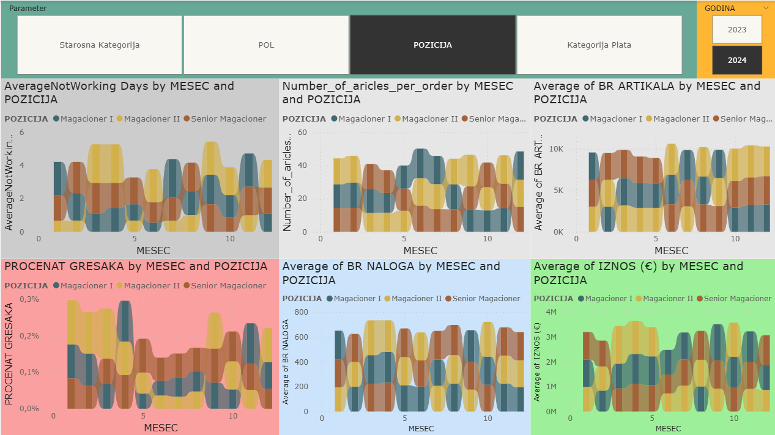
SUMMARY EVALUATION BY POSITION
Position | Efficiency | Quality | Attendance | Work Volume | Contribution (€) | Comment
Senior Warehouseman | 🔝 High | ✅ Fewest errors | ✅ Good presence | 🔝 Largest | 💰 High | Balanced, most valuable
Warehouseman II | 🟡 High | ❌ Many errors | ❌ Frequent absences | 🟠 Medium | 💰 Highest | Needs supervision, but generates revenue
Warehouseman I | 🟢 Stable | ✅ Decent quality | ✅ Present | 🔽 Smallest | 💰 Lowest | Good basics, lower contribution

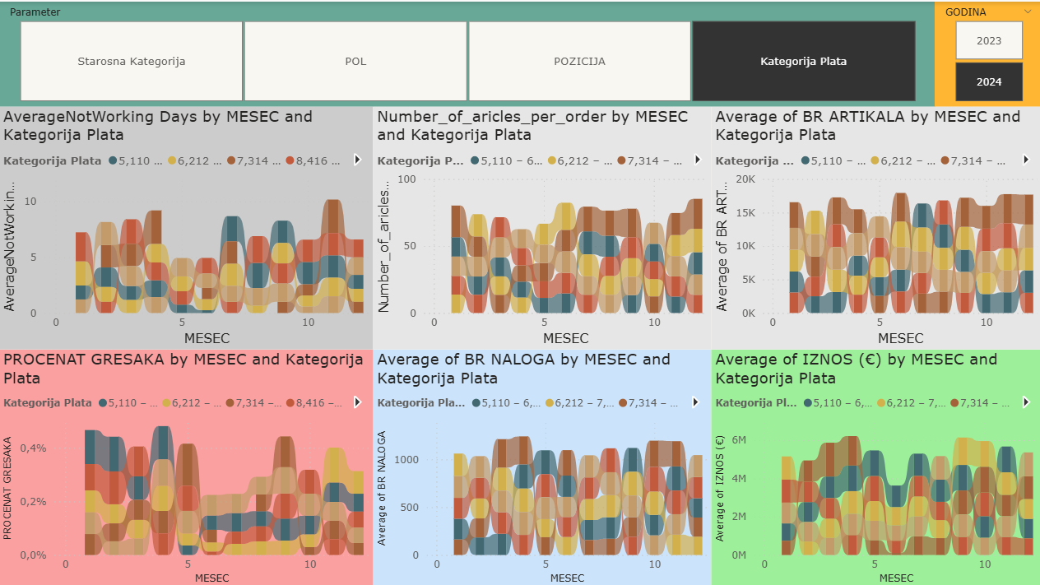

Conclusion
- Errors increase with salary – especially in the middle/higher pay ranges (€7,314–9,517), which suggests:
  - Higher-level tasks/responsibilities
  - Larger workload → increased risk of errors
- The salary group €6,212 – 7,313 (yellow) seems the most optimal:
  - Low error rate, stable performance, good balance between workload and results
- The highest salaries (gold) are not necessarily the most efficient, but they can be the most influential in key months
Recommendations for further action:
- Monitor if high salaries come with excessive workload – a possible sign of needing support or task redistribution
- Further investigate why the middle salary group achieves such a good balance – could serve as a training model for others

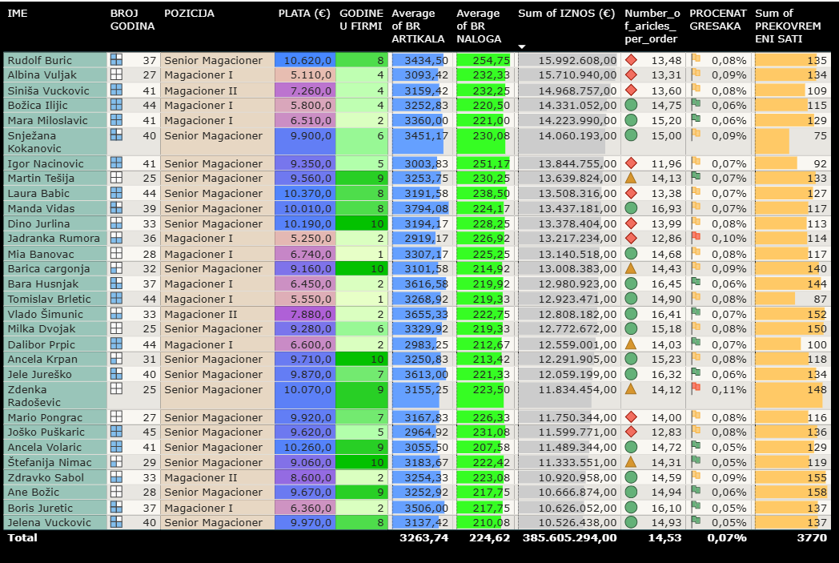
Consider salary increases for Barica Cargonja, Dalibor Prpić, Božica Ilijić, Bara Husnjak, Tomislav Brletić, and Jadranka Rumora – because they demonstrate:
- High performance,
- Strong dedication,
- Low salary compared to colleagues.

Recommended employees for discussion due to poorer performance:
Name | Note
Zdenka Radošević | Highest error percentage
Martin Tešlija | Expensive, below average
Dino Jurlina | Below average on KPIs
Manda Vidas | Good performance but borderline
Jadranka Rumora | Low salary but underperforming
Laura Babić | Expensive, lower productivity
Martin Pongrac | Below average in everything except salary
Joško Puškarić | Below average output, high salary

Note:
These discussions should not be disciplinary, but rather focus on:
- Understanding causes (e.g., technical issues, training, workload)
- Providing opportunities for improvement
- Setting goals for the upcoming period

FOR APPOINTMENT WITH LAURA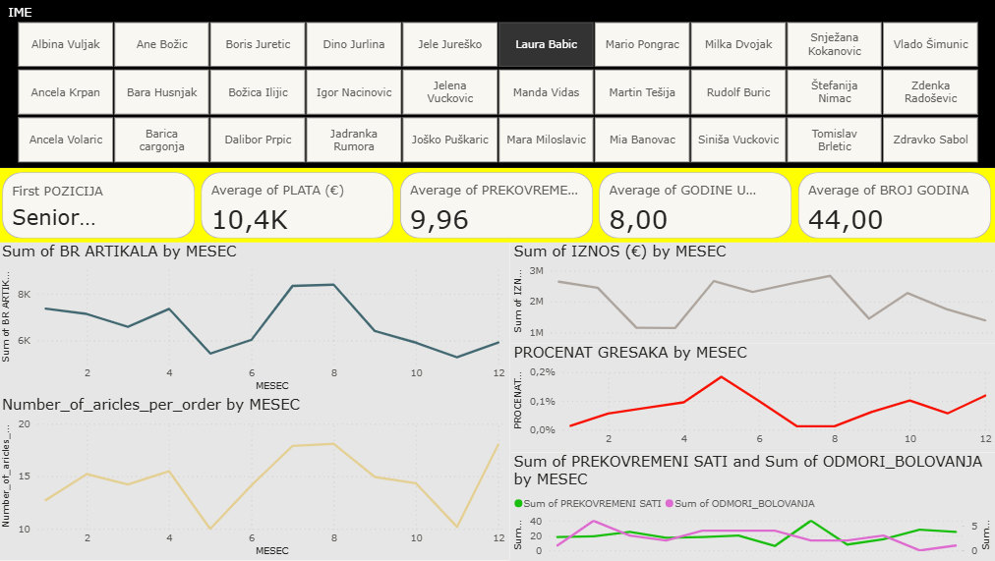
Laura, thank you for joining us today.
We’d like to take a moment to recognize both your contributions and explore some areas where we can provide support or make improvements together.
🔹 What You’re Doing Well:
- You’re holding a Senior position, which reflects your experience and the trust placed in you.
- Your average monthly salary (€10,400) is aligned with that level of responsibility, and your 8 years of experience at the company confirm your stability and dedication.
- At 44 years old, you bring maturity and valuable insight to the team.
- We’ve noticed high productivity, especially in months 6 to 8, where your output of processed articles was notably strong.
- Also, your articles per order ratio has been improving recently — that’s a great sign of increasing efficiency.
🔸 Where We See Some Challenges:
- We’ve observed a rise in error percentage in recent months, particularly after month 4. This may suggest fatigue, task complexity, or something else — we want to understand that better.
- You’re averaging nearly 10 overtime hours per month, which raises the question of whether your workload might be too heavy and if that’s impacting performance.
- There are some fluctuations in your time off as well, so it may be helpful to look into how rest and recovery are being balanced with your work demands.
🗣 How We’d Like to Support You:
- We’d like to hear your perspective — are there specific challenges or bottlenecks contributing to the increase in errors?
- Do you feel overloaded or under pressure, and is there something we can do to help balance that?
- Going forward, we’d like to work with you to set some focused goals, particularly around error reduction while maintaining or even enhancing your productivity.
- Finally, if you feel you need additional training, tools, or a shift in workload, we’re open to discussing how we can support that.

Your contribution is valuable, Laura, and this conversation is not a criticism — it’s an opportunity for collaboration. We're here to help you succeed and continue to be a strong performer in the team.
Let us know your thoughts.

